Docker and Kubernetes

1. Create VM

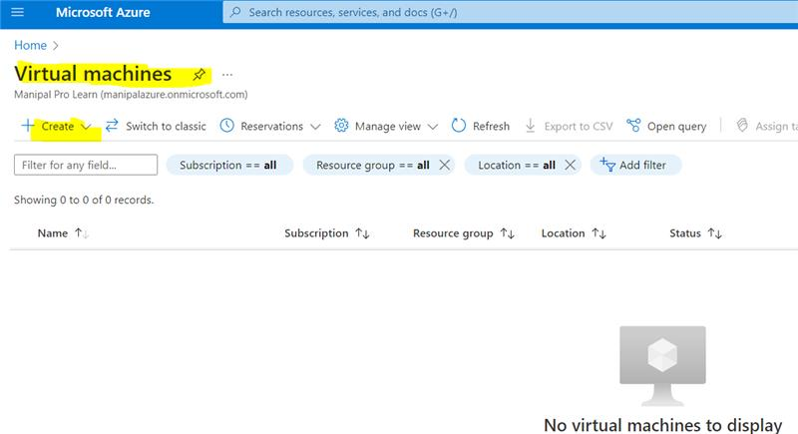

1. Resource group – Contains meta data of all azure services.

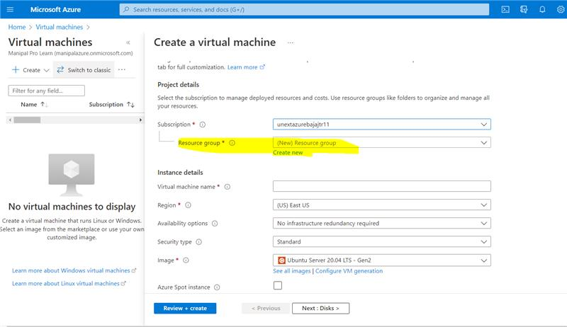

3.

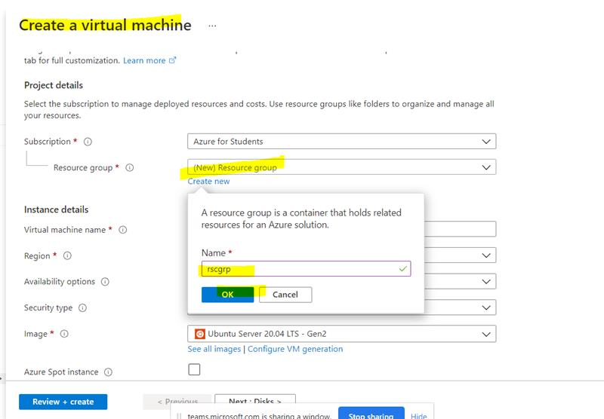

4.

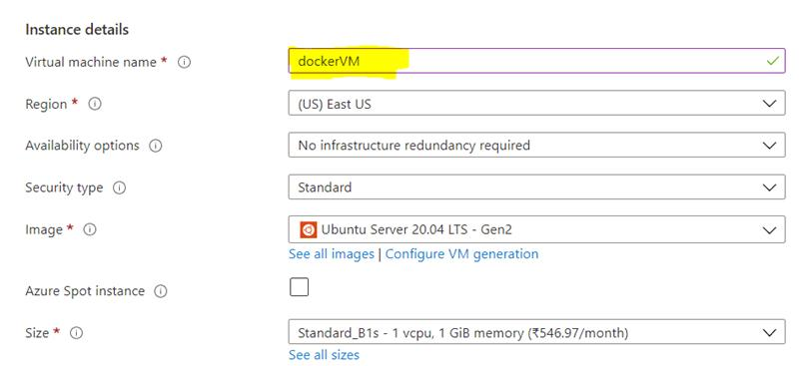

5.

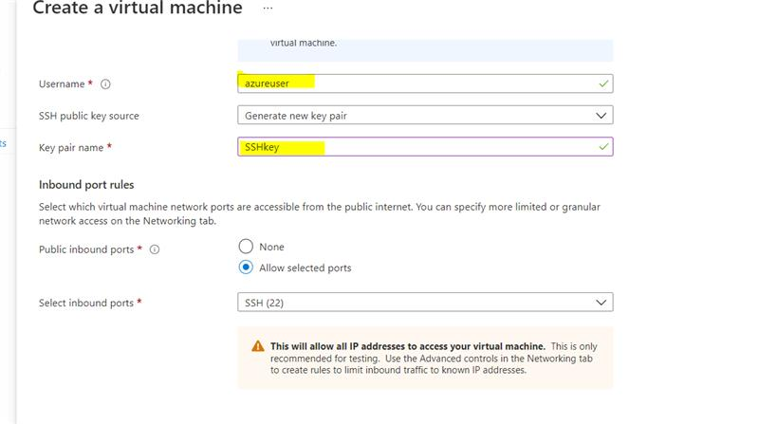

6.

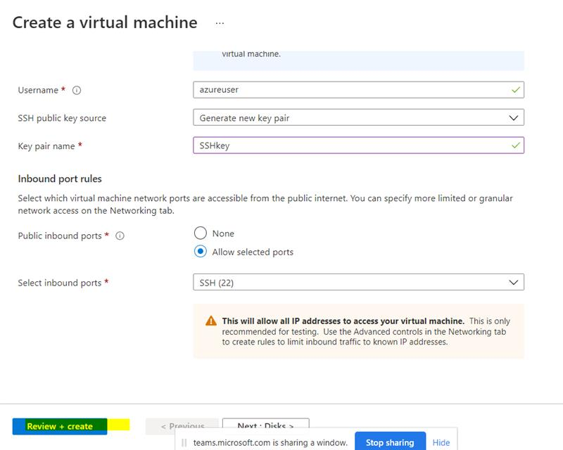

7.

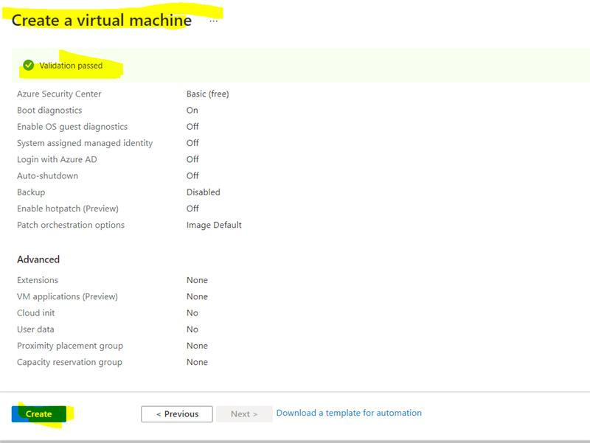

8.

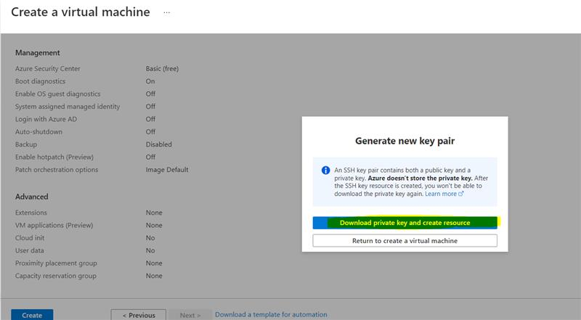

A SSHkey.pem file will be downloaded.

9.

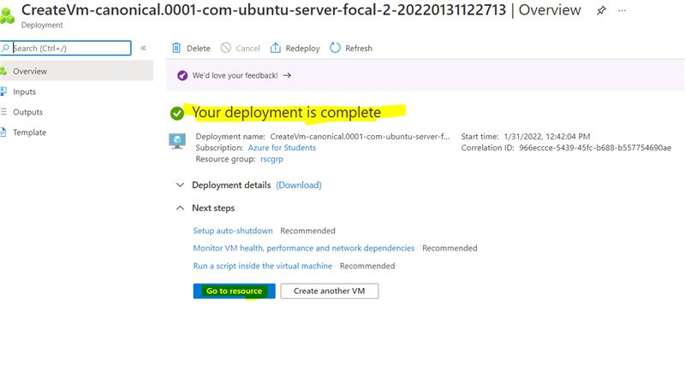

10.

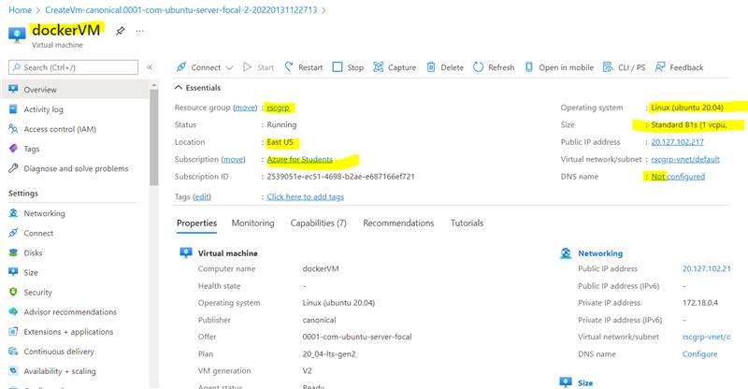

11.

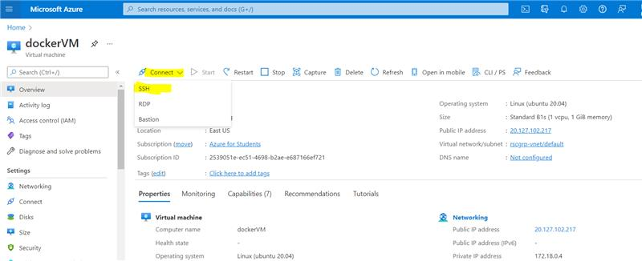

12. Connect to the VM - ssh -i C:\Users\Mayank\Downloads\demoSSHkey.pem azureuser@40.76.51.68

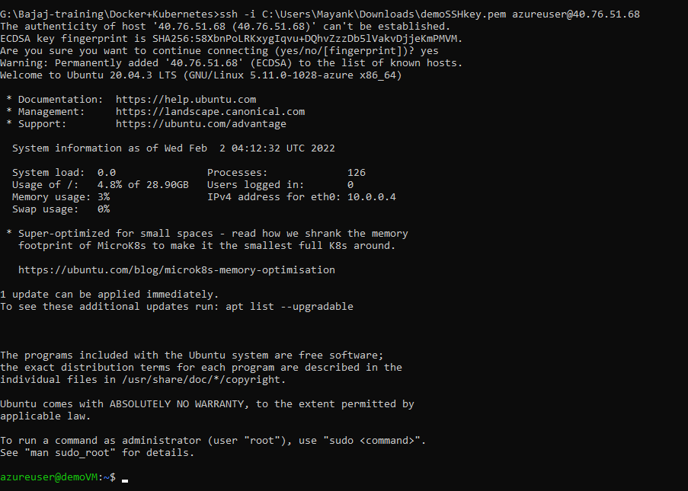

13. sudo apt-get update

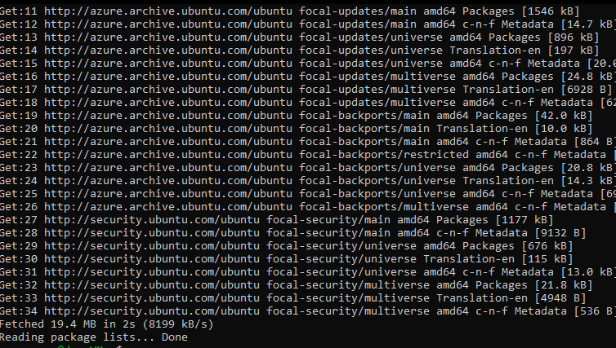

14. sudo apt install docker.io

docker --version

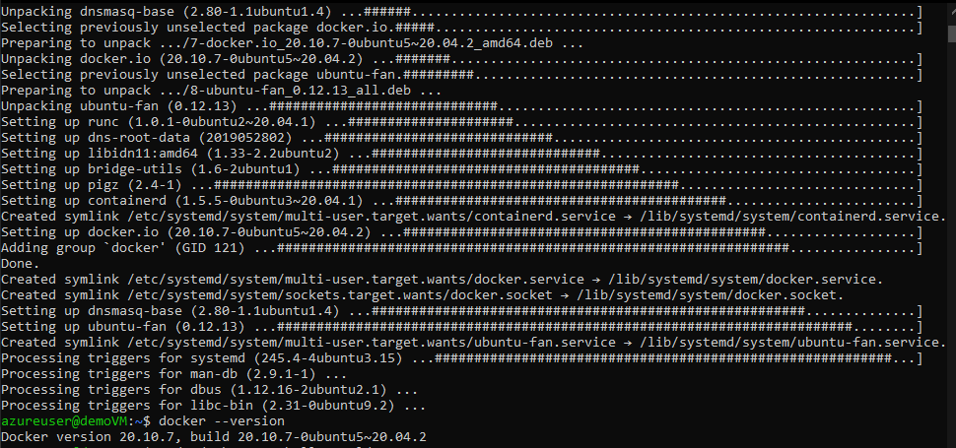

15. sudo docker run hello-world

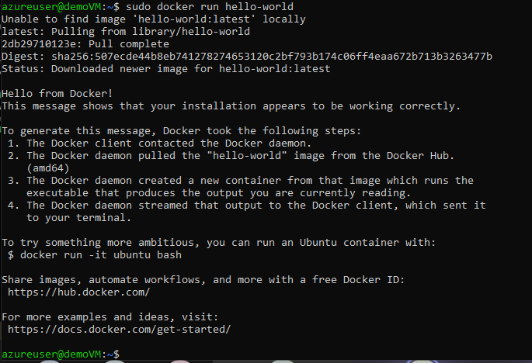

16. sudo docker images – shows installed docker images

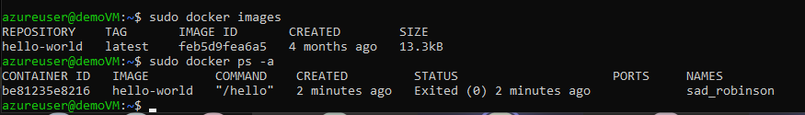

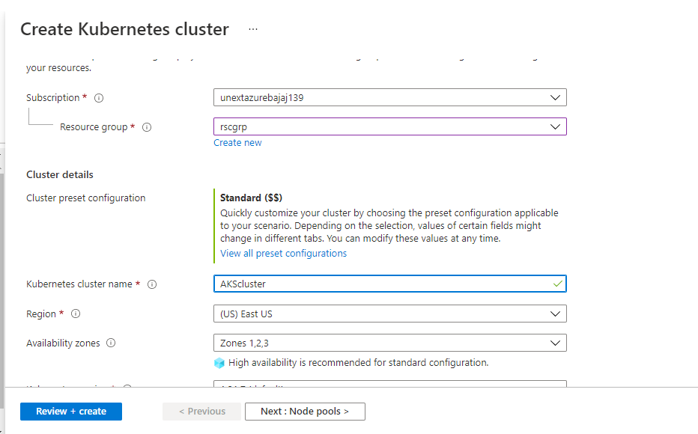

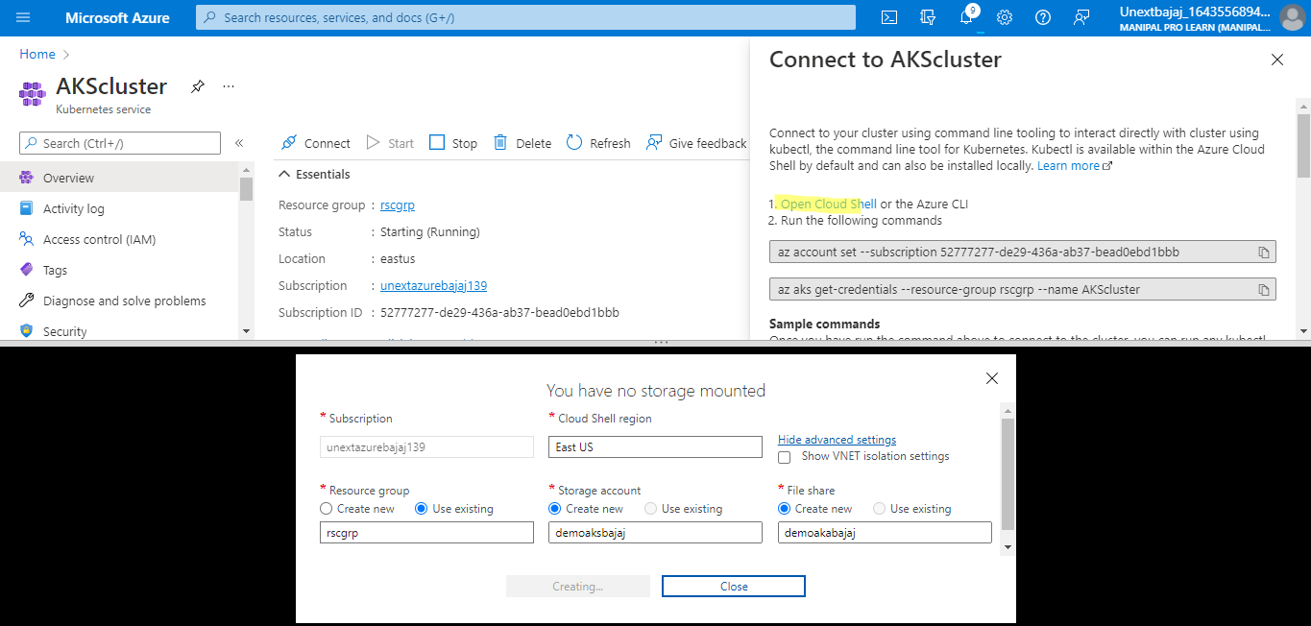

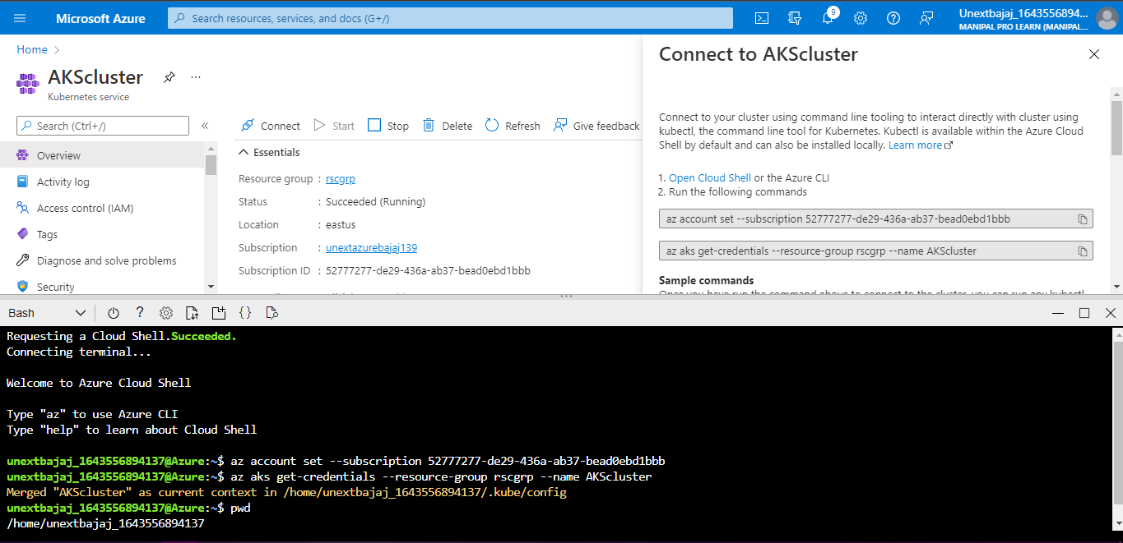

az – to open the azure CLI

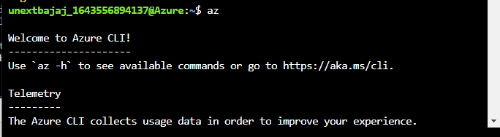

kubectl –

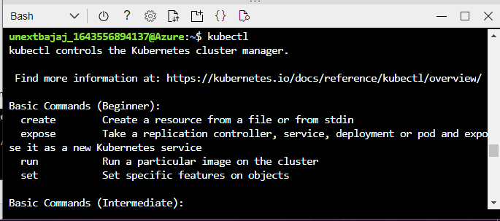

az aks get-credentials --resource-group rscgrp --name AKScluster

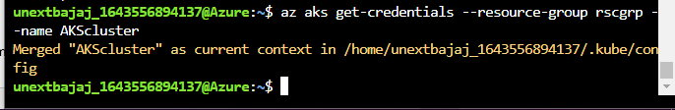

kubectl get nodes – shows the nodes in the Kubernetes cluster

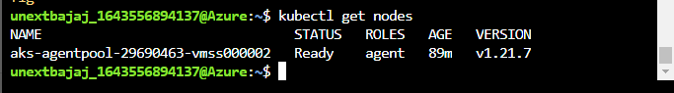

So far, all the commands were for connecting to the cluster.

vi azure-vote.yaml

Paste the below code in the file. First press i to enter into insert mode then paste the text and press esc. :w – to write to the file. :x – To exit.

apiVersion: apps/v1  
kind: Deployment  
metadata:  
name: azure-vote-back  
spec:  
replicas: 1  
selector:  
matchLabels:  
app: azure-vote-back  
template:  
metadata:  
labels:  
app: azure-vote-back  
spec:  
nodeSelector:  
"kubernetes.io/os": linux  
containers:  
- name: azure-vote-back  
image: mcr.microsoft.com/oss/bitnami/redis:6.0.8  
env:  
- name: ALLOW_EMPTY_PASSWORD  
value: "yes"  
resources:  
requests:  
cpu: 100m  
memory: 128Mi  
limits:  
cpu: 250m  
memory: 256Mi  
ports:  
- containerPort: 6379  
name: redis  
---  
apiVersion: v1  
kind: Service  
metadata:  
name: azure-vote-back  
spec:  
ports:  
- port: 6379  
selector:  
app: azure-vote-back  
---  
apiVersion: apps/v1  
kind: Deployment  
metadata:  
name: azure-vote-front  
spec:  
replicas: 1  
selector:  
matchLabels:  
app: azure-vote-front  
template:  
metadata:  
labels:  
app: azure-vote-front  
spec:  
nodeSelector:  
"kubernetes.io/os": linux  
containers:  
- name: azure-vote-front  
image: mcr.microsoft.com/azuredocs/azure-vote-front:v1  
resources:  
requests:  
cpu: 100m  
memory: 128Mi  
limits:  
cpu: 250m  
memory: 256Mi  
ports:  
- containerPort: 80  
env:  
- name: REDIS  
value: "azure-vote-back"  
---  
apiVersion: v1  
kind: Service  
metadata:  
name: azure-vote-front  
spec:  
type: LoadBalancer  
ports:  
- port: 80  
selector:  
app: azure-vote-front

kubectl apply -f azure-vote.yaml

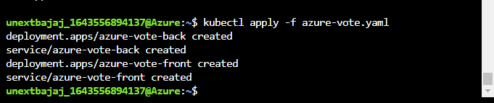

kubectl get service azure-vote-front –watch

open the web browser and type the external ip address of your service

